YouSaveIt WEBSITE
Proposal Document


TEAM: EAGLE
Version: V.1.1

Revision History
Date | Version | Description | Custodian/Organization
13/08/2013 | 1.0 | Initial publication. | EAGLE TEAM
22/08/2013 | 1.1 | Edit WBS, Schedule | Trần Công Bình

Table of Contents
1. Introduction 2
1.1 Purpose 2
1.2 Scope 2
2. Description of Project 3
2.1 Business need 3
2.2 Benefits 3
2.3 High level features 3
2.4 Additional features 4
2.5 Non-functional 4
2.6 Estimated Project Costs 5
3. Resource 6
3.1 Human resource 6
3.2 Technology 7
3.3 System environments 7
4. Process 8
4.1 Process overview 8
2.1.1. Advantage 8
4.2 Work Breakdown Structure 9
4.3 Plan 9
Appendix A: Glossary 10
Appendix B: Reference Documents 11
Appendix C: Approval 12

Introduction

Purpose
- The purpose of this document is to explain the proposed solution, show benefit of the project and the way it work.
- Provide overview about solution, resources, budget, and schedule for the project.

Scope
The scope of document is providing:
- Business need
- Summary solution
- Process
- Project resource
- Schedule
- High level function and non-function
- Technology
- Stakeholder and user
- Cost
- Constrains
- Risk

Description of Project

Business need
- The waste is happening every day in life. We often throw the unnecessary stuff, but don't know that may be needed with other people, and we can swap the items or sell for other people to get the necessary items with bargain cost.
- Resources are running out, swap items with other people will help avoid waste, save cost and protect the environment. And in Vietnam we don’t know any website do these things, that’s why we created the website to help them to do that.

Benefits
In addition to benefits such as:
- Swap items
- Saving cost
- Protect environment
Then, the website will have revenue through banner ads placed on the website, and from the intermediary services on the website when users want to exchange but cannot be exchanged directly.

High level features
- Posting information about swap item
- Searching information about swap item
- Consignment
- Send swap request
- Etc...

Additional features
- Connect to social networks Facebook, Google, yahoo (log in with the account)
- Online chat

Non-functional
Performance
- The system responds in less than 2 seconds for 95% of uses.
- The system responds in less than 20 seconds for 100% of uses.
- The system support 10,000 additional users added in the month.
- The system supports 500 new users signing up and initiating within the same hour.
Security
- The administrator will actively remove suspicious accounts; fail to comply with the way the website works.
Usability
- The system will have the instructions on how to log information, and online support to respond the needs of the user.
Availability
- 24 x 7 x 365
Open – APIs, system integration and interfaces. E.g. social media…

Estimated Project Costs
Cost for first year
Cost Type | Estimated Unit Price  ($)
Domain & Hosting costs
- Domain (1 year) | 15
- Hosting (1 year) | 50
Product cost (1)
- Implement | 1700
Facilities costs (structural) (2)
- Photo documents | 50
- Meeting cost (drink, internet, electricity...) | 300
COST TOTAL = (1)+(2) | 2050

Resource

Human resource
Project team
No. | Name | E-mail | Role
1 | Trịnh Kim Sanh  Nguyễn Thị Trùng Dương | sanhtk@yahoo.com khucnam@yahoo.com | Mentor, Investor
2 | Trần Công Bình | congbinh24k@gmail.com | Project Leader
3 | Trịnh Thị Phượng | ttphuong1012@gmail.com | Quality Manager
4 | Nguyễn Thanh Minh Hiếu | nguyenthanhminhhieu@gmail.com | Development Manager
5 | Trịnh Tiến Đạt | tiendattrinh07@gmail.com | Support Manager

Technical skill
- Analysis and design of information systems
- Have good knowledge at database management system : MySQL, MS SQL …
- Have good knowledge at : HTML&CSS, ASP.NET, PHP, C# …
- Good skill at office software: Microsoft Word, Excel, Power Point, Photoshop…
Soft skill
- Communication skill
- Presentation skill
- Time management skill
- Teamwork skill
- Knowledgeable and friendly
Experience
- Having three-year experience in project
- Achieving good result in studying and doing project

Technology
- Language: HTML&CSS, PHP, Java Script...
- Development tools: Dreamweaver, Xampp...
- Development environments: Windows 7, Windows 8, Ubuntu 12.04 LTS, Web…

System environments
Server
- Hosting: Linux OS
- Capacity: 2 Gb
- Bandwidth: 50 Gb
Client
- System operation: Windows 7, Windows 8, Ubuntu, iOS, Android …
- Browser: Firefox, chrome, Opera, IE …

Process
Base on advantage and disadvantage of human resource, we decided to use Team Software Process (TSP) to run project.

Process overview
Team Software Process (TSP) guides engineering teams that are developing software-intensive products. Using TSP helps organizations establish a mature and disciplined engineering practice that produces secure, reliable software in less time and at lower costs.
TSP has been applied in small and large organizations in a variety of domains with similar results on first use, including
- Productivity improvements of 25% or more
- Reductions in cost and schedule variance to less than +/- 10%
- Testing costs and schedule reductions of up to 80%

Advantage
- Iterative
- Highly discipline which will help members make the best quality products
- Members work dependence, support and communicate with each other
- TSP use improves the quality and productivity of engineering teams while helping them to more precisely meet cost and schedule commitments.
- TSP is one of a series of methods can help engineering teams to more effectively develop and support software-intensive systems. CMM provides the overall improvement framework needed for effective engineering work .The Personal Software Process (PSP) provides the engineering disciplines that engineers need for consistently using a defined, planned, and measured process. The TSP couples the principles of integrated product teams with the PSP and CMM methods to produce effective teams

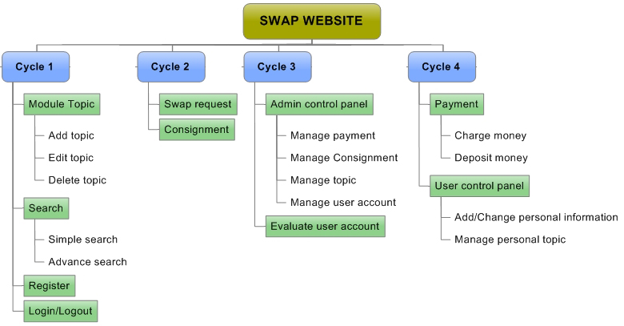
Work Breakdown Structure

Figure 1: Swap website work breakdown structure

Plan
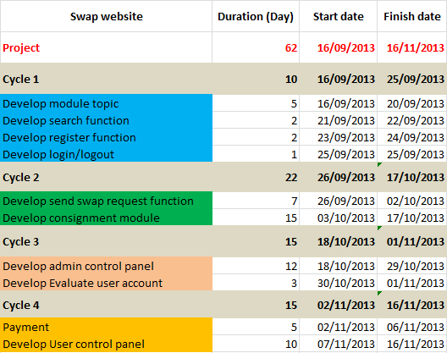

Figure 2: High level plan

Appendix A: Glossary
WBS
Work breakdown structure
TSP
Team software process
PSP
Personal Software Process
CMM
Capability Maturity Model

Appendix B: Reference Documents
Title | Nomenclature
Information System Life Cycle Manual | Treasury Directive Publication (TD P 84-01), Version 3.2, March 2002
United States Mint SDLC | Version 1.1 May 2002
OCIO United States Mint CM Standards and Procedures | Version 2.0, June 2002
United States Mint Project Documentation Guide | Version 3, June 2002
Software Engineering Institute (SEI), Carnegie Mellon University, Key Practices of the Capability Maturity Model

Appendix C: Approval
Prepared by | Signature | Date
Tran Cong Binh
K16CMU-TTT
Approved by | Signature | Date
Tran Kim Sanh
Mentor
Duy Tan University

Nguyen Trinh Trung Duong
Mentor
Duy Tan University

